Carter, Murray (from CALM news 2000)
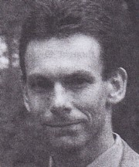
Graduated from Dwellingup Cadet School in 1986. In 15 years with CALM he worked in Pemberton (as forest ranger and ranger in charge), Katanning (as District Manager) and Blackwood (an amalgamation of Nannup and Kirup) as District Manager. He was a forest ranger, ranger-in-charge and finally Blackwood District Manager In 2000, He resigned to join the NSW Parks and Wildlife Service, as operations manager of Lord Howe Island. He returned to CALM and was Manager of Fire Management Services in 2011. Principal Fire Operations Officer Department of Parks and Wildlife 2012. Has been involved in operational fire management for over 25 years. He is currently Manager of the Department of Parks and Wildlife Fire Management Services Branch, Chair of AFAC’s Rural and Land Management Group and a member of the National Forest Fire Management Group. He is a strong advocate for ensuring and promoting an appropriate balance between risk mitigation activities and response activities in the context of bushfire management.

